Tutorial – 3
1. Draw a real picture for class and object. Differentiate class and object in terms of diagram only.

Perform following tasks.
Task 1: Create a class
Task 2: Add few data members as private
Task 3: Add few methods as public to work on defined data members
Task 4: Create a Demo class with main method.
Task 5: Create at least two objects of a class defined in Task 1 into main method and call all methods using that object.
Task 6: Write comment for each important portion of code like data members’ declaration, methods, some important logic etc.
Task 7: Summarize above solution in your own few words to visualize the solution to the end user.

using System;
using System.Collections.Generic;
using System.Linq;
using System.Text;
using System.Threading.Tasks;

namespace Tutorial___3
{
class Demo1
{
private int id = 0;
private string name = string.Empty;

public int getId()
{
return id;
}
public string getName()
{
return name;
}
public void setId(int id)
{
this.id = id;
}
public void setName(string name)
{
this.name = name;
}
}
internal class demo
{
public static void demoMethod()
{
Demo1 demo1 = new Demo1();
Demo1 demo2 = new Demo1();

demo1.setId(12);
demo2.setName("Hemal Rashiya");

Console.WriteLine("Your id : " + demo1.getId());
Console.WriteLine("Your name : " + demo2.getName());
}

}

Output:
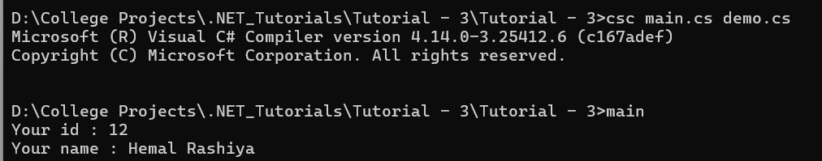

2. Define a class Clock with three private integer data members hour, min and sec. Define a no argument constructor to initialize time value to 12:00:00. Define a three argument constructor to initialize the time.
Define a methods to
  - Increment time to next second.
  - Display the time value.
  - Return the hour (int getHour())
  - Return the minute (int getMinute())
  - Return the seconds (int getSeconds())++++++++++++++++

using System;
using System.Collections.Generic;
using System.Linq;
using System.Text;
using System.Threading.Tasks;

namespace Tutorial___3
{
class Clock
{
private int hour = 0;
private int minute = 0;
private int second = 0;

public Clock(int hour,int minute, int second){
this.hour = hour;
this.minute = minute;
this.second = second;
}

public void displayTime()
{
Console.WriteLine("time : "+hour +":" + minute + ":" + second);
}

public void incrementTime()
{
second += 1;
if(second > 60)
{
second = 0;
minute += 1;
}else if(minute > 60)
{
minute = 0;
hour += 1;
}else if(hour > 24)
{
hour = 0;
}
}
public int getHour()
{
return hour;
}

public int getMinute()
{
return minute;
}

public int getSecond()
{
return second;
}
}
internal class T2
{
public static void t2()
{

Clock clock = new Clock(12, 00, 00);
clock.incrementTime();
clock.displayTime();
}

}
}

Output:
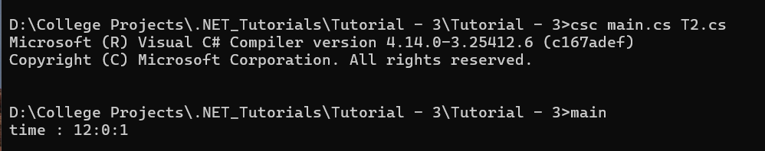

3. Define a Student class with appropriate data members, property, constructors, methos etc. Define another class called TestStudent within the same .cs file. Also create an object of student class and demonstrate the use of student class.

using System;
using System.Collections.Generic;
using System.Linq;
using System.Text;
using System.Threading.Tasks;

namespace Tutorial___3
{
public class Student
{
// Data members (fields)
private int rollNo;
private string name;
private int age;
private string course;

// Properties
public int RollNo
{
get { return rollNo; }
set { rollNo = value; }
}

public string Name
{
get { return name; }
set { name = value; }
}

public int Age
{
get { return age; }
set
{
if (value > 0)
age = value;
else
Console.WriteLine("Age must be positive.");
}
}

public string Course
{
get { return course; }
set { course = value; }
}

// Default Constructor
public Student()
{
rollNo = 0;
name = "Unknown";
age = 0;
course = "Not Assigned";
}

// Parameterized Constructor
public Student(int rollNo, string name, int age, string course)
{
this.rollNo = rollNo;
this.name = name;
this.Age = age; // using property for validation
this.course = course;
}

// Method to Display Student Details
public void DisplayDetails()
{
Console.WriteLine("Student Details:");
Console.WriteLine($"Roll No: {RollNo}");
Console.WriteLine($"Name : {Name}");
Console.WriteLine($"Age : {Age}");
Console.WriteLine($"Course : {Course}");
}
}

// TestStudent class in same file
public class T3
{
public static void t3()
{
// Creating object using default constructor
Student s1 = new Student();
s1.DisplayDetails();

Console.WriteLine();

Student s2 = new Student(101, "Hemal Rashiya", 44, "Computer Engineering");
s2.DisplayDetails();

Console.WriteLine();

s1.RollNo = 102;
s1.Name = "Aarav";
s1.Age = 19;
s1.Course = "Information Technology";

Console.WriteLine("Updated Student Details:");
s1.DisplayDetails();

Console.ReadLine();
}
}
}

Output:
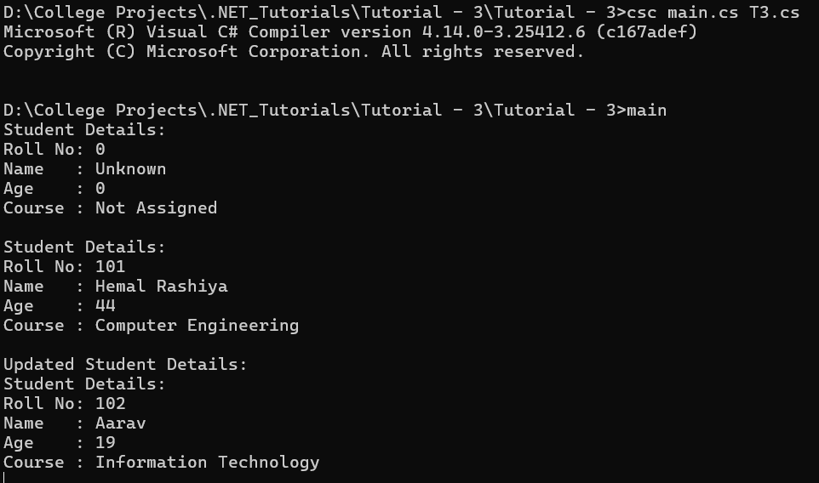
4. Use above program classes and create objects for 5 students and demonstrate the use student class.
using System;
using System.Collections.Generic;
using System.Linq;
using System.Text;
using System.Threading.Tasks;

namespace Tutorial___3
{
using System;

namespace StudentDemo
{
// Student class definition
public class Student
{
// Data members (fields)
private int rollNo;
private string name;
private int age;

// Property for RollNo
public int RollNo
{
get { return rollNo; }
set { rollNo = value; }
}

// Property for Name
public string Name
{
get { return name; }
set { name = value; }
}

// Property for Age
public int Age
{
get { return age; }
set
{
if (value > 0)
age = value;
else
throw new ArgumentException("Age must be greater than 0");
}
}

// Default constructor
public Student()
{
rollNo = 0;
name = "Unknown";
age = 0;
}

// Parameterized constructor
public Student(int rollNo, string name, int age)
{
this.rollNo = rollNo;
this.name = name;
this.age = age;
}

// Method to display student info
public void DisplayInfo()
{
Console.WriteLine($"Roll No: {rollNo}, Name: {name}, Age: {age}");
}
}

// Test class in same file
class T4
{
public static void t4()
{
// Creating 5 student objects using constructor
Student s1 = new Student(1, "Hemal", 21);
Student s2 = new Student(2, "Rahul", 20);
Student s3 = new Student(3, "Neha", 22);
Student s4 = new Student(4, "Karan", 19);
Student s5 = new Student(5, "Priya", 23);

// Displaying info of each student
Console.WriteLine("Student Details:\n");
s1.DisplayInfo();
s2.DisplayInfo();
s3.DisplayInfo();
s4.DisplayInfo();
s5.DisplayInfo();

Console.ReadLine();
}
}
}

}
Output:
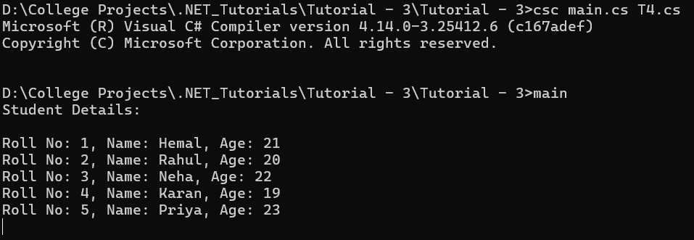
5. Rearrange the given code to get the desired output.
using System;
using System.Collections.Generic;
using System.Linq;
using System.Net.Mime;
using System.Text;
using System.Threading.Tasks;

namespace Tutorial___3
{

class Product
{
string pcode;
string pname, mname;

// Constructor
public Product(string pcd, string pnm, string mnm)
{
pcode = pcd;
pname = pnm;
mname = mnm;
}

// Display method
public void Display()
{
Console.WriteLine("\nProduct Code:= " + pcode);
Console.WriteLine("\nProduct Name:= " + pname);
Console.WriteLine("\nManufacturer Name:= " + mname);
}
}

public class T5
{
public static void t5(string[] args)
{
int n = args.Length;

if (n < 3)
{
Console.WriteLine("Syntax Error\n");
Console.WriteLine("Must Have THREE Arguments\n");
Console.WriteLine("Please, Write as [csc TestProduct ProductCode ProductName Manufacturer] \n");
}
else
{
string pcd = args[0];
string pnm = args[1];
string mnm = args[2];

Product p = new Product(pcd, pnm, mnm);
p.Display();

Console.Read();
}
}
}
}

Output:-
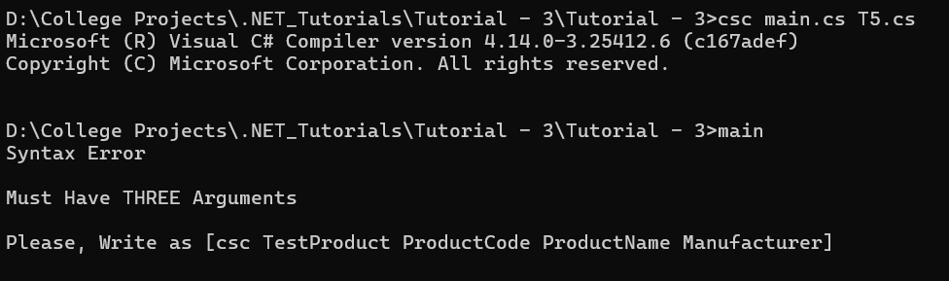
6. Complete the following code that will generate the given output:
using System;
using System.Collections.Generic;
using System.Linq;
using System.Text;
using System.Threading.Tasks;
namespace Tutorial___3
{
class Line
{
private double length;
public Line()
{
Console.WriteLine("Object is being created, length = 10");
length = 10;
}
public void setLength(double len)
{
length = len;
}
public double getLength()
{
return length;
}
}
class T6
{
public static void t6()
{
Line line = new Line();
Console.WriteLine("Length of line : {0}", line.getLength());
line.setLength(6);
Console.WriteLine("Length of line : {0}", line.getLength());
Console.ReadKey();
}
}
}
Output:-
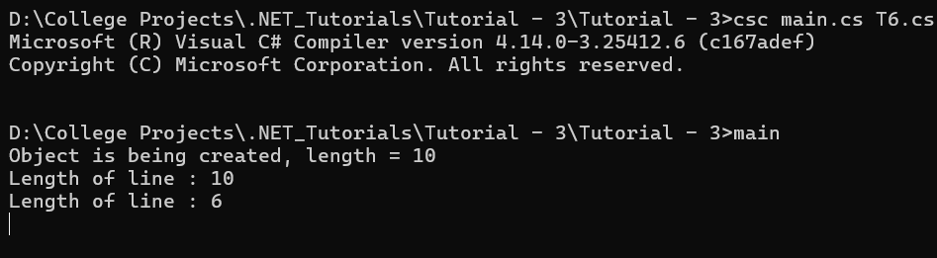
7. Define EnrolmentNo and Name properties for the Student class and demonstrate use of these properties along with required data members, methods and constructors.
using System;
using System.Collections.Generic;
using System.Linq;
using System.Text;
using System.Threading.Tasks;

namespace Tutorial___3
{
class Student1
{
// Data members (fields)
private string enrolmentNo;
private string name;

// Property for EnrolmentNo
public string EnrolmentNo
{
get { return enrolmentNo; }
set { enrolmentNo = value; }
}

// Property for Name
public string Name
{
get { return name; }
set
{
if (!string.IsNullOrEmpty(value))
name = value;
else
throw new ArgumentException("Name cannot be empty");
}
}

// Default constructor
public Student1()
{
enrolmentNo = "N/A";
name = "Unknown";
}

// Parameterized constructor
public Student1(string enrolNo, string nm)
{
enrolmentNo = enrolNo;
name = nm;
}

// Method to display student info
public void DisplayInfo()
{
Console.WriteLine($"Enrolment No: {enrolmentNo}, Name: {name}");
}
}

class T7
{
public static void t7()
{
// Using default constructor
Student1 s1 = new Student1();
s1.DisplayInfo();

// Using parameterized constructor
Student1 s2 = new Student1("E001", "Hemal");
s2.DisplayInfo();

// Using properties to set values
Student1 s3 = new Student1();
s3.EnrolmentNo = "E002";
s3.Name = "Rahul";
s3.DisplayInfo();

Console.ReadLine();
}
}
}

Output:-
